**4.Aim: a) Basic Spring Boot Application with Auto-Wiring.**

**Description:**

This is a **basic Spring Boot application** that demonstrates **Auto-Wiring** and **Bean Scopes**.

* The **Student** class depends on the **Marks** class, and Spring automatically injects Marks into Student using **@Autowired**.
* **@Component** is used to register both classes (Student and Marks) as Spring Beans.
* In the main class “**AutowiringApplication**”, we retrieve the Student bean from the **ApplicationContext** and call its methods along with the Marks methods.

**Folder Structure:**

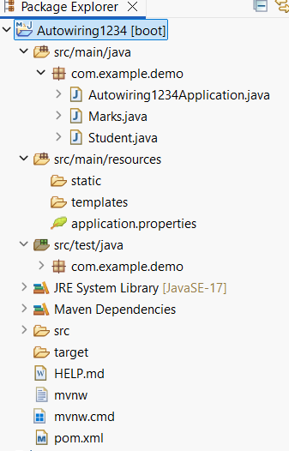

**Program:**

**Marks.java**

**package** com.example.demo;

**import** org.springframework.stereotype.Component;

@Component

**public** **class** Marks {

**public** **void** display() {

System.**out**.println("marks class display method");

}

**public** **void** read() {

System.**out**.println("marks class read method");

}

}

**Student.java**

**package** com.example.demo;

**import** org.springframework.beans.factory.annotation.Autowired;

**import** org.springframework.stereotype.Component;

@Component

**public** **class** Student {

@Autowired

**public** Marks m;

**public** **void** display() {

System.**out**.println("student class display method");

}

}

**Autowiring1234Application.java**

**package** com.example.demo;

**import** org.springframework.boot.SpringApplication;

**import** org.springframework.boot.autoconfigure.SpringBootApplication;

**import** org.springframework.context.ApplicationContext;

@SpringBootApplication

**public** **class** Autowiring1234Application {

**public** **static** **void** main(String[] args) {

ApplicationContext

context=SpringApplication.run(Autowiring1234Application.**class**, args);

Student s=context.getBean(Student.**class**);

s.display();

s.m.display();

s.m.read();

}

}

**application.properties**

spring.application.name=Autowiring

server.port=0000

**pom.xml**

<?xml version="1.0" encoding="UTF-8"?>

<project xmlns="http://maven.apache.org/POM/4.0.0" xmlns:xsi="http://www.w3.org/2001/XMLSchema-instance"

xsi:schemaLocation="http://maven.apache.org/POM/4.0.0 https://maven.apache.org/xsd/maven-4.0.0.xsd">

<modelVersion>4.0.0</modelVersion>

<parent>

<groupId>org.springframework.boot</groupId>

<artifactId>spring-boot-starter-parent</artifactId>

<version>3.5.5</version>

<relativePath/> <!-- lookup parent from repository -->

</parent>

<groupId>com.example</groupId>

<artifactId>Autowiring1234Application</artifactId>

<version>0.0.1-SNAPSHOT</version>

<name>Autowiring1234</name>

<description>Demo project for Spring Boot</description>

<url/>

<licenses>

<license/>

</licenses>

<developers>

<developer/>

</developers>

<scm>

<connection/>

<developerConnection/>

<tag/>

<url/>

</scm>

<properties>

<java.version>17</java.version>

</properties>

<dependencies>

<dependency>

<groupId>org.springframework.boot</groupId>

<artifactId>spring-boot-starter-web</artifactId>

</dependency>

<dependency>

<groupId>org.springframework.boot</groupId>

<artifactId>spring-boot-starter-test</artifactId>

<scope>test</scope>

</dependency>

</dependencies>

<build>

<plugins>

<plugin>

<groupId>org.springframework.boot</groupId>

<artifactId>spring-boot-maven-plugin</artifactId>

</plugin>

</plugins>

</build>

</project>

**Output:**

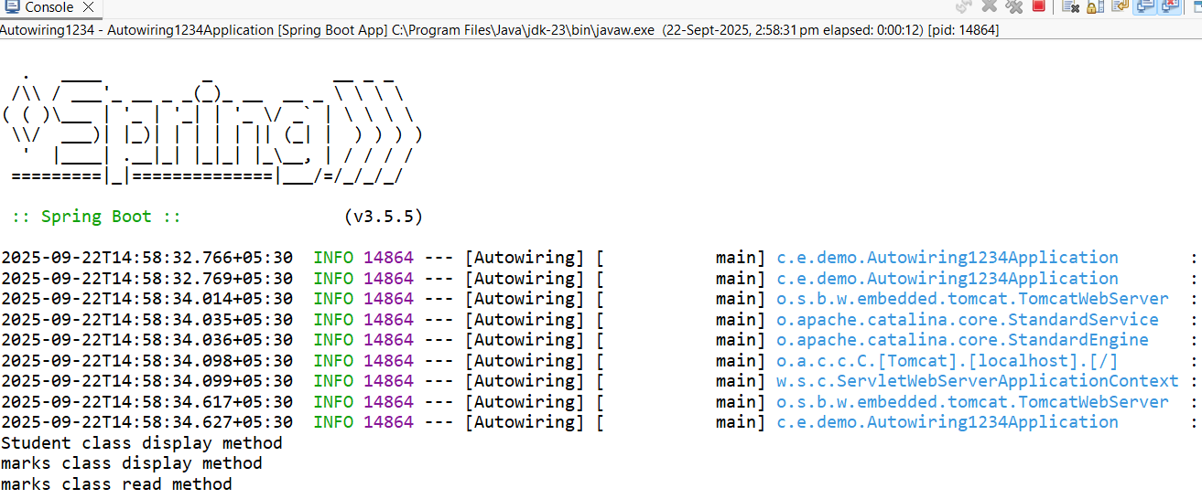

**4.Aim: b) Basic Spring Boot Application with Bean Scopes.**

**Description:**

This program explains the difference between **Singleton** and **Prototype** bean scopes in Spring Boot:

* **Singleton Scope** (@Scope("singleton")): Only one instance of the bean is created for the entire Spring container. Any request for that bean will return the same instance.
* **Prototype Scope** (@Scope("prototype")): A new instance of the bean is created every time it is requested from the container.
* SingletonBean is shared across requests. Changes in one reference affect the other. Where in PrototypeBean creates new objects each time, so changes in one object do not affect another.

**Program:**

**ScopeDemo123Application.java**

**package** com.example.demo;

**import** org.springframework.boot.SpringApplication;

**import** org.springframework.boot.autoconfigure.SpringBootApplication;

**import** org.springframework.context.ConfigurableApplicationContext;

@SpringBootApplication

**public** **class** ScopeDemo123Application {

**public** **static** **void** main(String[] args) {

ConfigurableApplicationContext

context=SpringApplication.run(ScopeDemo123Application.**class**, args);

SingletonBean sb1=context.getBean(SingletonBean.**class**);

SingletonBean sb2=context.getBean(SingletonBean.**class**);

sb1.setCount(100);

sb2.setCount(200);

System.**out**.println(sb1.getCount());

System.**out**.println(sb2.getCount());

PrototypeBean pb1=context.getBean(PrototypeBean.**class**);

PrototypeBean pb2=context.getBean(PrototypeBean.**class**);

pb1.setCount(700);

pb2.setCount(900);

System.**out**.println(pb1.getCount());

System.**out**.println(pb2.getCount());

}

}

**SingletonBean.java**

**package** com.example.demo;

**import** org.springframework.beans.factory.annotation.Value;

**import** org.springframework.context.annotation.Scope;

**import** org.springframework.stereotype.Component;

@Component

@Scope("singleton")

**public** **class** SingletonBean {

@Value("36")

**public** **int** count;

**public** **int** getCount() {

**return** count;

}

**public** **void** setCount(**int** count) {

**this**.count = count;

}

}

**PrototypeBean.java**

**package** com.example.demo;

**import** org.springframework.beans.factory.annotation.Value;

**import** org.springframework.context.annotation.Scope;

**import** org.springframework.stereotype.Component;

@Component

@Scope("prototype")

**public** **class** PrototypeBean {

@Value("69")

**public** **int** count;

**public** **int** getCount() {

**return** count;

}

**public** **void** setCount(**int** count) {

**this**.count = count;

}

}

**application.properties**

spring.application.name=ScopeDemo123

server.port=0000

**pom.xml**

<?xml version="1.0" encoding="UTF-8"?>

<project xmlns="http://maven.apache.org/POM/4.0.0" xmlns:xsi="http://www.w3.org/2001/XMLSchema-instance"

xsi:schemaLocation="http://maven.apache.org/POM/4.0.0 https://maven.apache.org/xsd/maven-4.0.0.xsd">

<modelVersion>4.0.0</modelVersion>

<parent>

<groupId>org.springframework.boot</groupId>

<artifactId>spring-boot-starter-parent</artifactId>

<version>3.5.5</version>

<relativePath/> <!-- lookup parent from repository -->

</parent>

<groupId>com.example</groupId>

<artifactId>ScopeDemo123Application</artifactId>

<version>0.0.1-SNAPSHOT</version>

<name>ScopeDemo123</name>

<description>Demo project for Spring Boot</description>

<url/>

<licenses><license/>

</licenses>

<developers>

<developer/>

</developers>

<scm>

<connection/>

<developerConnection/>

<tag/>

<url/>

</scm>

<properties>

<java.version>17</java.version>

</properties>

<dependencies>

<dependency>

<groupId>org.springframework.boot</groupId>

<artifactId>spring-boot-starter-web</artifactId>

</dependency>

<dependency>

<groupId>org.springframework.boot</groupId>

<artifactId>spring-boot-starter-test</artifactId>

<scope>test</scope>

</dependency>

</dependencies>

<build>

<plugins>

<plugin>

<groupId>org.springframework.boot</groupId>

<artifactId>spring-boot-maven-plugin</artifactId>

</plugin>

</plugins>

</build>

</project>

**Output:**

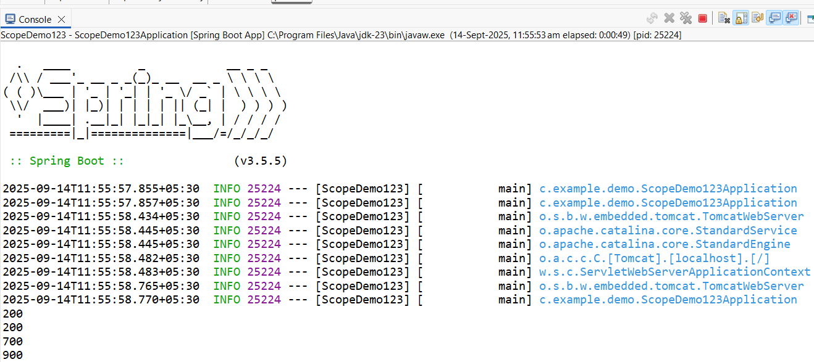

**5.Aim: Basic Spring Boot Application with Bean Scopes.**

**Description:**

This program demonstrates how to implement **logging** in a Spring Boot application using **SLF4J (Simple Logging Facade for Java)** and **LoggerFactory**.

* We created a **LogController** that logs messages at different log levels: **TRACE, DEBUG, INFO, WARN** & **ERROR**.
* The logging behavior is configured in **application.properties**.
* Another controller **MyController** is added to test a simple message response.

**Program:**

**LogController.java**

**package** com.example.demo;

**import** org.slf4j.Logger;

**import** org.slf4j.LoggerFactory;

**import** org.springframework.web.bind.annotation.RequestMapping;

**import** org.springframework.web.bind.annotation.RestController;

@RestController

**public** **class** LogController {

Logger logger= LoggerFactory.getLogger(LogController.**class**);

@RequestMapping("/log")

**public String log() {**

log.trace("log level:trace");

log.info("log level:info");

log.debug("log level:debug");

log.error("log level:error");

log.warn("log level:warn");

**return "hey you can check the op in the log";**

**}**

}

**MyController.java**

**package** com.example.demo;

**import** org.springframework.web.bind.annotation.GetMapping;

**import** org.springframework.web.bind.annotation.RestController;

@RestController

**public** **class** MyController {

@GetMapping("/msg")

**public** String msg()

{

**return**("Spring Boot application successfully executed");

}

}

**LoggerApplication.java**

**package** com.example.demo;

**import** org.springframework.boot.SpringApplication;

**import** org.springframework.boot.autoconfigure.SpringBootApplication;

@SpringBootApplication

**public** **class** LoggerApplication {

**public** **static** **void** main(String[] args) {

SpringApplication.run(LoggerApplication.**class**, args);

}

}

**application.properties**

spring.application.name=Logger

logging.level.root=INFO

logging.level.com.example=DEBUG

server.port=0000

**pom.xml**

<?xml version="1.0" encoding="UTF-8"?>

<project xmlns="http://maven.apache.org/POM/4.0.0" xmlns:xsi="http://www.w3.org/2001/XMLSchema-instance"

xsi:schemaLocation="http://maven.apache.org/POM/4.0.0 https://maven.apache.org/xsd/maven-4.0.0.xsd">

<modelVersion>4.0.0</modelVersion>

<parent>

<groupId>org.springframework.boot</groupId>

<artifactId>spring-boot-starter-parent</artifactId>

<version>3.5.5</version>

<relativePath/> <!-- lookup parent from repository -->

</parent>

<groupId>com.example</groupId>

<artifactId>LoggerApplication</artifactId>

<version>0.0.1-SNAPSHOT</version>

<name>Logger</name>

<description>Demo project for Spring Boot</description>

<url/>

<licenses>

<license/>

</licenses>

<developers>

<developer/>

</developers>

<scm>

<connection/>

<developerConnection/>

<tag/>

<url/>

</scm>

<properties>

<java.version>17</java.version>

</properties>

<dependencies>

<dependency>

<groupId>org.springframework.boot</groupId>

<artifactId>spring-boot-starter-web</artifactId>

</dependency>

<dependency>

<groupId>org.springframework.boot</groupId>

<artifactId>spring-boot-starter-test</artifactId>

<scope>test</scope>

</dependency>

</dependencies>

<build>

<plugins>

<plugin>

<groupId>org.springframework.boot</groupId>

<artifactId>spring-boot-maven-plugin</artifactId>

</plugin>

</plugins>

</build>

</project>

**Output:**

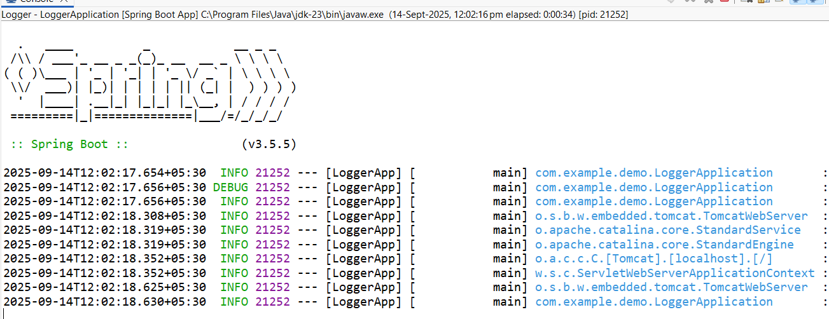

**6.Aim: Implementing and Using AOP in Spring Boot**

**Description:**

Aspect-Oriented Programming (AOP) in Spring Boot is used to separate cross-cutting concerns (like logging, transactions, security) from the main business logic.

In this example:

* We create a Service **(MyService)** that prints a message.
* We define an Aspect **(MyAspect)** with **@Before** and **@After** advice that runs before and after the **sayHello()** method.
* The Main Application **(TodayApplication)** runs the service using CommandLineRunner.
* Dependencies in pom.xml include “**spring-boot-starter-aop**” to enable AOP support.

**Program:**

**MyAspect2.java**

**package** com.example.demo;

**import** org.aspectj.lang.annotation.After;

**import** org.aspectj.lang.annotation.Aspect;

**import** org.aspectj.lang.annotation.Before;

**import** org.springframework.stereotype.Component;

@Aspect

@Component

**public** **class** MyAspect2 {

@Before("execution(* com.example.demo.MyService2.sayHello(..))")

**public** **void** beforeMethod() {

System.**out**.println("Before: Method is about to run");

}

@After("execution(* com.example.demo.MyService2.sayHello(..))")

**public** **void** afterMethod() {

System.**out**.println("After: Method has run");

}

}

**MyService2.java**

**package** com.example.demo;

**import** org.springframework.stereotype.Service;

@Service

**public** **class** MyService2 {

**public** **void** sayHello() {

System.**out**.println("welcome to aop programming");

}

}

**Today3Application.java**

**package** com.example.demo;

**import** org.springframework.boot.CommandLineRunner;

**import** org.springframework.boot.SpringApplication;

**import** org.springframework.boot.autoconfigure.SpringBootApplication;

@SpringBootApplication

**public** **class** Today3Application **implements** CommandLineRunner{

**private** **final** MyService2 myservice;

**public** Today3Application(MyService2 myservice) {

**this**.myservice = myservice;

}

**public** **static** **void** main(String[] args) {

SpringApplication.run(Today3Application.**class**, args);

}

@Override

**public** **void** run(String... args) {

myservice.sayHello();

}

}

**application.properties**

spring.application.name=Today3

server.port=0000

**pom.xml**

<?xml version="1.0" encoding="UTF-8"?>

<project xmlns="http://maven.apache.org/POM/4.0.0" xmlns:xsi="http://www.w3.org/2001/XMLSchema-instance"

xsi:schemaLocation="http://maven.apache.org/POM/4.0.0 https://maven.apache.org/xsd/maven-4.0.0.xsd">

<modelVersion>4.0.0</modelVersion>

<parent>

<groupId>org.springframework.boot</groupId>

<artifactId>spring-boot-starter-parent</artifactId>

<version>3.5.5</version>

<relativePath/> <!-- lookup parent from repository -->

</parent>

<groupId>com.example</groupId>

<artifactId>Today3Application</artifactId>

<version>0.0.1-SNAPSHOT</version>

<name>Today3</name>

<description>Demo project for Spring Boot</description>

<url/>

<licenses>

<license/>

</licenses>

<developers>

<developer/>

</developers>

<scm>

<connection/>

<developerConnection/>

<tag/>

<url/>

</scm>

<properties>

<java.version>17</java.version>

</properties>

<dependencies>

<dependency>

<groupId>org.springframework.boot</groupId>

<artifactId>spring-boot-starter-web</artifactId>

</dependency>

<dependency>

<groupId>org.springframework.boot</groupId>

<artifactId>spring-boot-starter-test</artifactId>

<scope>test</scope>

</dependency>

<dependency>

<groupId>org.springframework.boot</groupId>

<artifactId>spring-boot-starter-aop</artifactId>

</dependency>

</dependencies>

<build>

<plugins>

<plugin>

<groupId>org.springframework.boot</groupId>

<artifactId>spring-boot-maven-plugin</artifactId>

</plugin>

</plugins>

</build>

</project>

**Output:**

